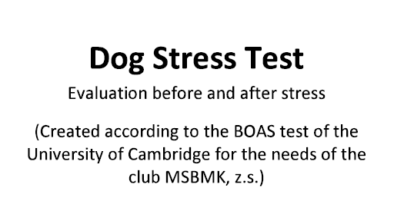 

|  |  |
| --- | --- |
| **Registred name:** |  |
| **Breed:** |  |
| **Sex:** |  |
| **Color:** |  |
| **Date of birth (month-day-year):** |  |
| **IN number (Microchip):** |  |
| **Registred number:** |  |
| **Owner name, address:** |  |

**Assesasment**

|  |  |
| --- | --- |
| **Weith** |  |
| **Pulse befor burden** |  |
| **Pulse after burden** |  |

**Assesasment of the nose according to the attached design**

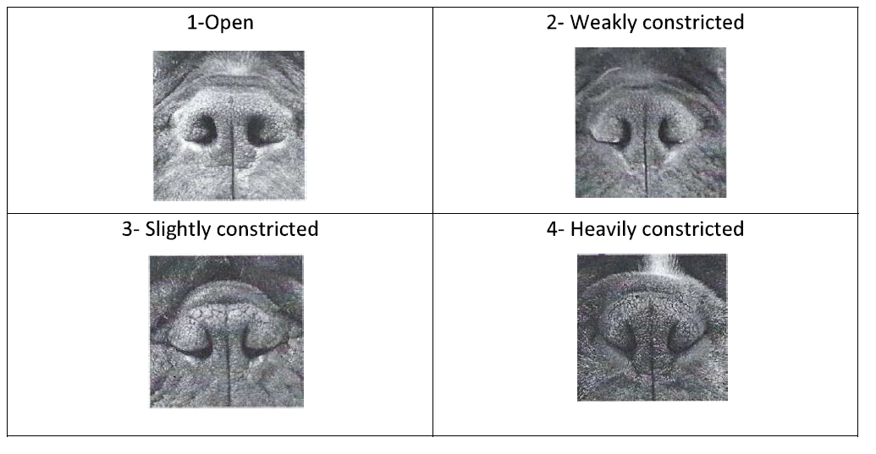

Date, signature and stamp of veterinarian:…………………………………………………………………………………………….

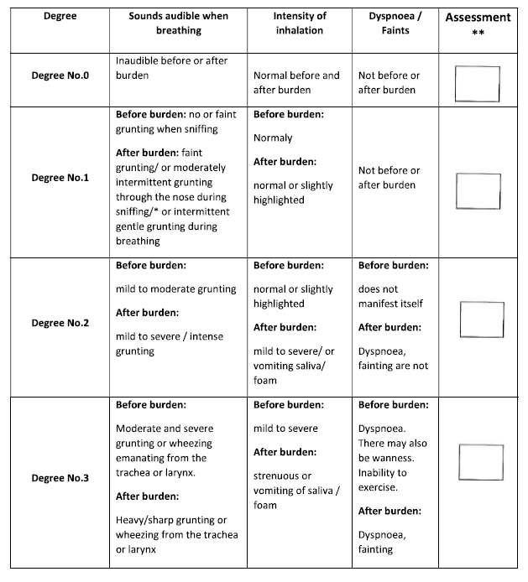

* Dogs with mild intermittent grunting when sniffing have a similar rate of BOAS as dogs with a slight respitatory sound, therefore they are classified as No. 1

** Mark the corresponding variant with a cross.

Other notes:

Recommendation of another examination: yes/no

Date, signature and stamp of veterinarian:……………………………………………………………………..